- INSTRUCTIONAL DECISION MAKING
MDD Standard 4 - 5
- The teacher candidate makes adjustments to the lesson plans based on assessment data and pupils’ engagement, communicating the analysis and conclusions regarding the impact of instruction.

3.1 Student Response to Lesson 1: Did the student(s) respond in the ways you had predicted? What do you think accounts for differences in student responses and learning? Consider motivation, management, understanding of instructions, complexity of task, and individualization to student ability.

Personally, I had troubles at the beginning of the class, due to this group is the larger at school. Moreover, the classroom, despite being the biggest, is not enough for this group. I takes a lot of time to calm students and make them pay attention to me (or the teacher).
Regarding tasks, Ss responded very well, they seem motivated and entertained by the tasks topics. The only problem was that the activities took a little bit longer than usual. As a result, Ss lose their focus.
I had no problems with understanding of instructions or individualization to Ss ability.

3.2 Adjustments for Lesson 1: Describe how you will adjust your second lesson in response to your analysis above. Consider instructional strategies, the organization and content of the lesson, motivational strategies, preventative management strategies, procedural changes, materials, activities and assessment. Explain why you believe these adjustments will improve student learning.

Personally, I believe that I am too flexible to students, and they might take advantage of it. Therefore, I need to stablish boundaries from the beginning to avoid the misuse of trust.
Regarding tasks, it is necessary to prepare more and shorter activities to maintain Ss focused. If the activity is too long they tend to lose focus and they start talking.

3.3 Analysis of Learning Results

3.3.1 Whole Class: Use the assessment data you collected to draw conclusions about the extent to which the class group attained all learning goals. Support all claims about student learning with observable data (e.g. student writing, test results, specific student comments, or observed student performances). Include samples of student work. (Attach these in the appendix.)

3.3.2 Individuals: Select two students that represent different levels or kinds of performance. Describe what these students learned in relation to two significant learning goals, one of which must represent higher-level learning. Use specific examples of the students' work including student writing, test results, specific student comments, or your observations to draw conclusions about the extent to which these students attained the learning goals.

3.3.2.1 Student 1

She is a student whose grades used to be low, despite she was always paying attention and taking notes. Moreover, she asked me for extra help. So, after giving instructions I used to approach to her and explaining her the instructions again or in a different way, using examples or doing the first exercise of the task. As a result, her grades improve substantially.
It is necessary to highlight that I don´t have records of her previous tests, but I will include one test, which was during my period with them.

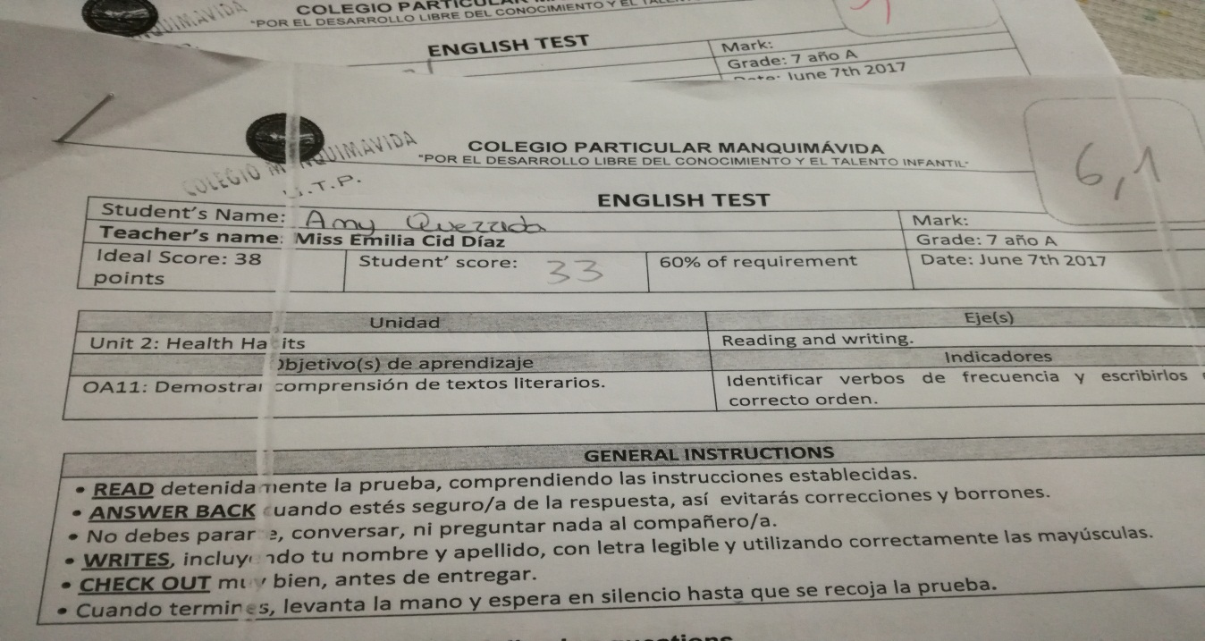

3.3.2.2 Student 2

He is a students whose level of proficiency is higher in comparison with his classmates. He has no problem on understanding instructions or task and he is always asking for more demanding tasks. For this I gave him a short book in English “Dr. Jekyll and Mr. Hyde” and ask him to discuss the book with me after class.
It is important to highlight that I don’t have record of those conversations, due to it was advised to me that it was not legal to record a student. For this reason, I will include his test results.

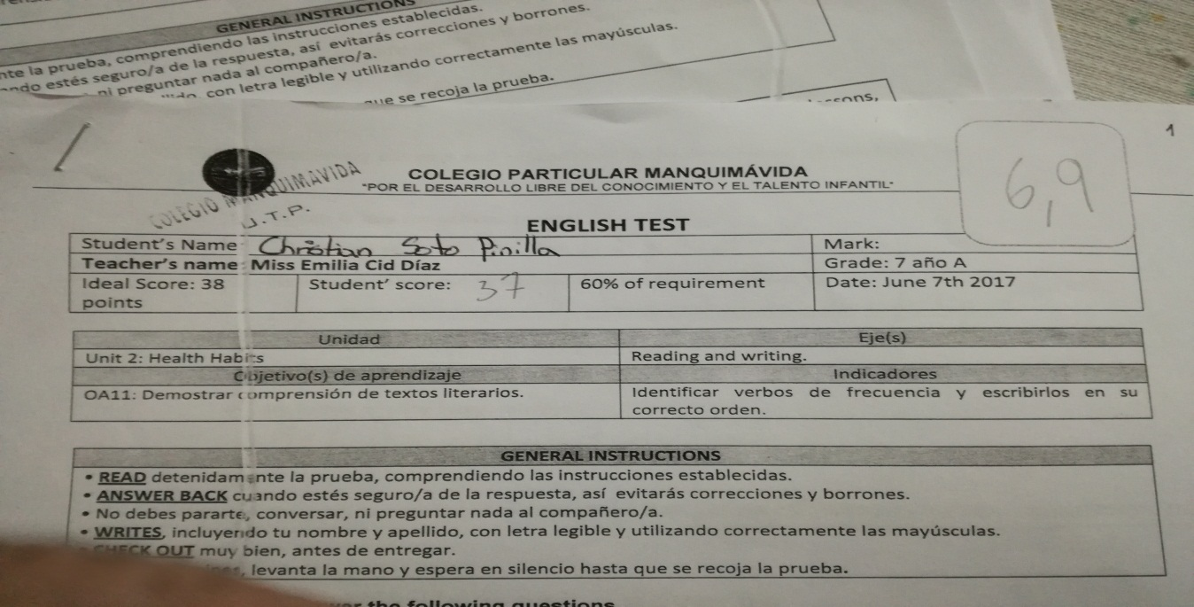

3.4 Impact of your instruction on Student Learning
3.4.1 Identify what you believe to be the instructional strategies and activities that contributed most to student learning.

I consider that the task topic is essential for students to feel motivated. If you, as teacher, choose appealing subjects for your Ss, they will engage in the task.

3.4.2 Explain how your teaching behaviors affected student learning. Consider student response to explaining, giving directions, modeling, organizing activities, leading discussions, the pacing of the lesson, and the overall organization of the lesson.

Despite students might take advantage of you if you are too flexible with them, at the same time their affective filter is very low, which make them feel comfortable of asking in case of doubts or express their opinion.

Repeat same sequence of prompts for Lesson 2

4.1 Identify two concrete aspects of your lesson planning, assessments or implementation of the lessons that you will do differently the next time you are asked to plan and deliver instruction to a group of students.

I will definitively stablish an appropriate distance on my role as a teacher/adult and the students/teenagers. Additionally, I will ask more about the different aspects that characterize a group of students, not only with the teacher tutor, but with other teachers, so I can make a more appropriate planning for the class.

APPENDIX.

This is one of the test created and approved by UTP.

